Main Agenda- Create a dropdown pick one class among many classes and show it’s rules versions status ruleset of selected class.

First we have a report in the data-rule-summary class and the report name is pyRulesByRuleset and we can save as this version into our ruleset and then include the filter as class name so that based on the class name we can get all the rules and the class.

Here we need to use that report pyRulesByRuleset and then we can get the report

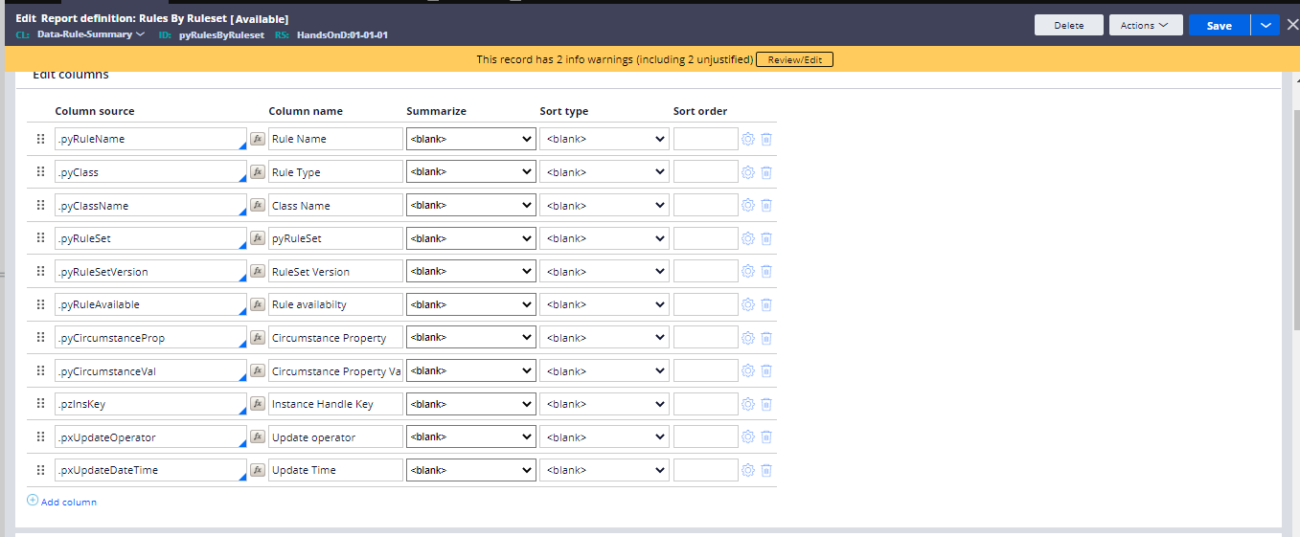

And pass the filters as the depending on class name

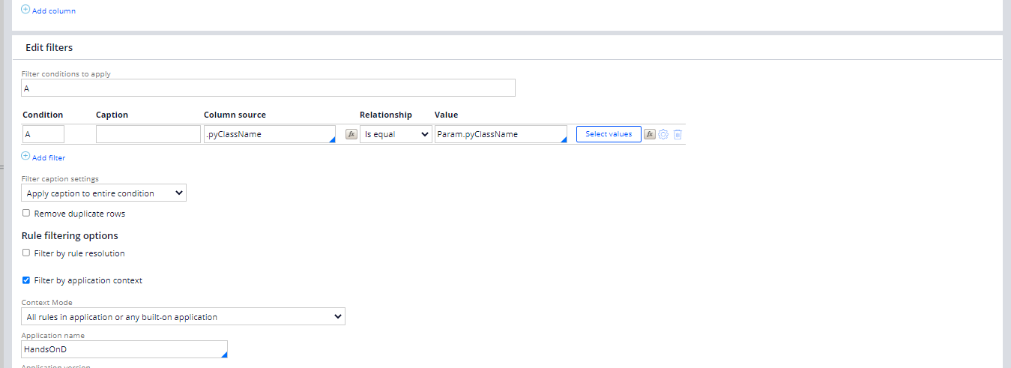

And the result would be

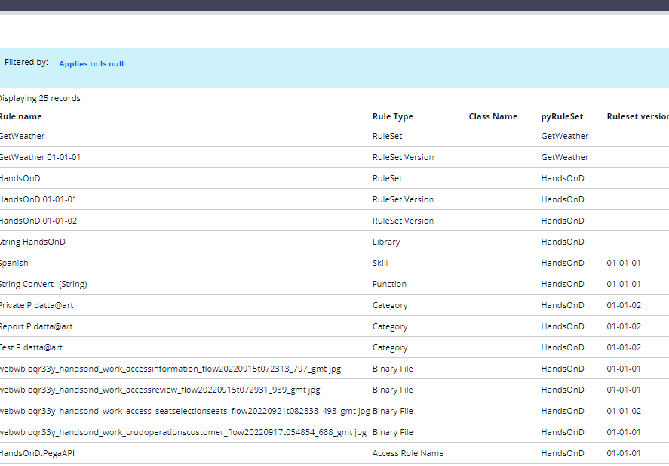

And for the reference of the report in table and refer our properties in the section

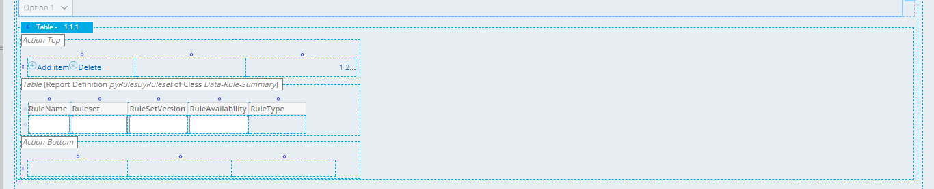

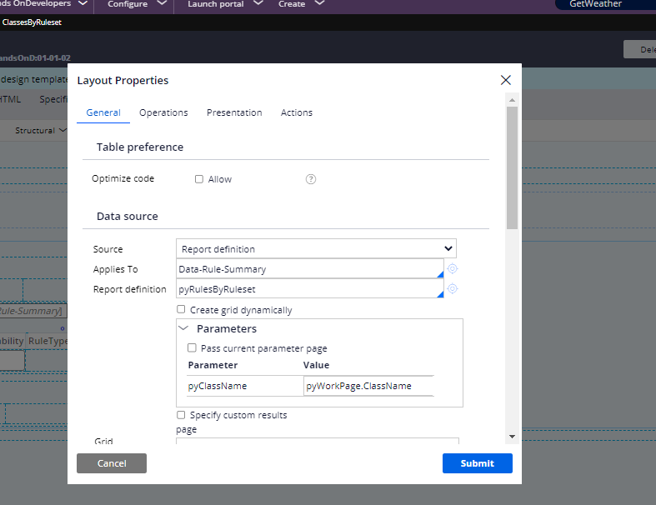

And in here we would have dropdown for which we would be needing another report to fetch classes

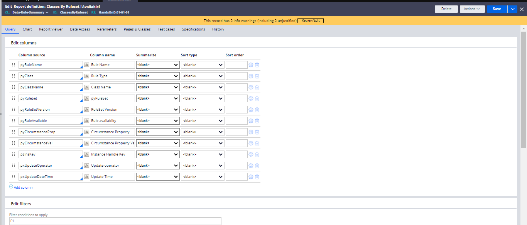

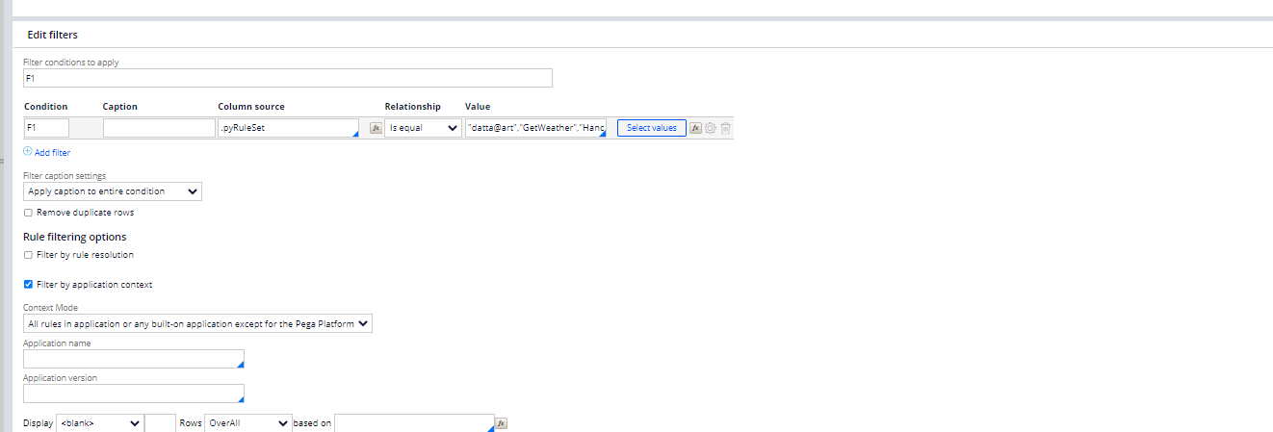

And then can get the class

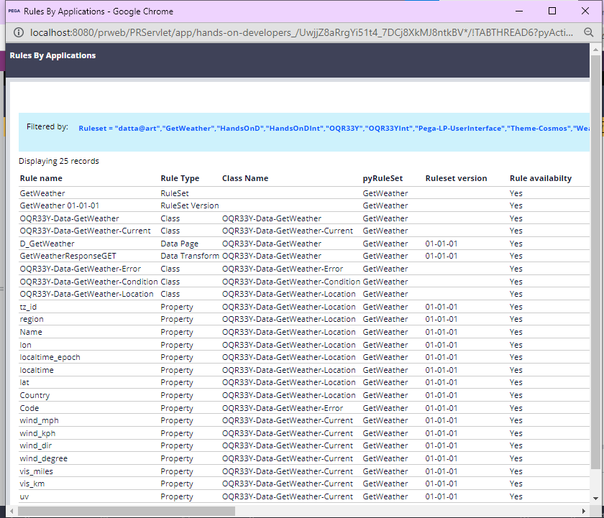

And can refer this in the dropdown for getting the classes

And then we can pass the report In dropdown and give the parameter as a class and go for the usage of this in the dropdown

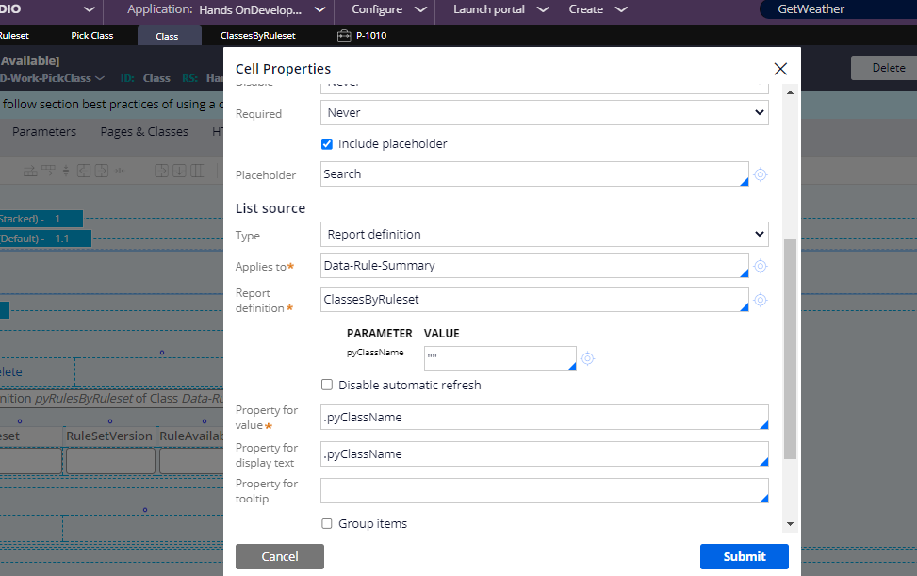

And after that we can create flow and go for the section plug in

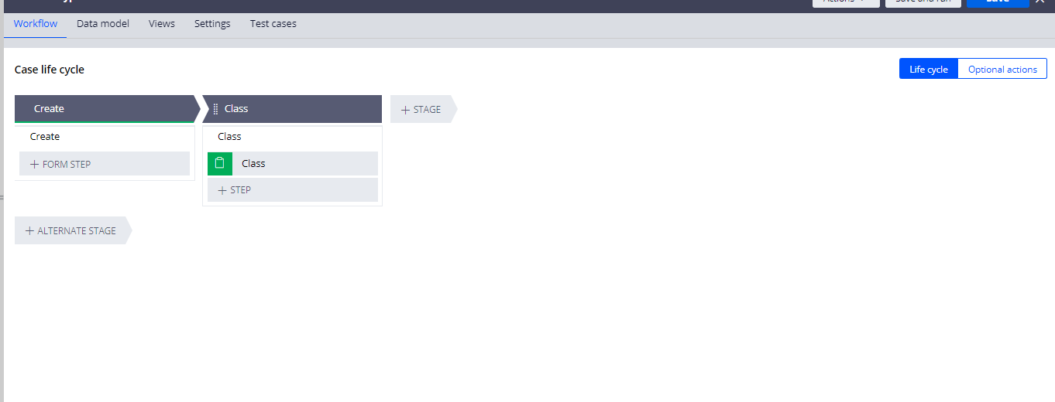

And now the section

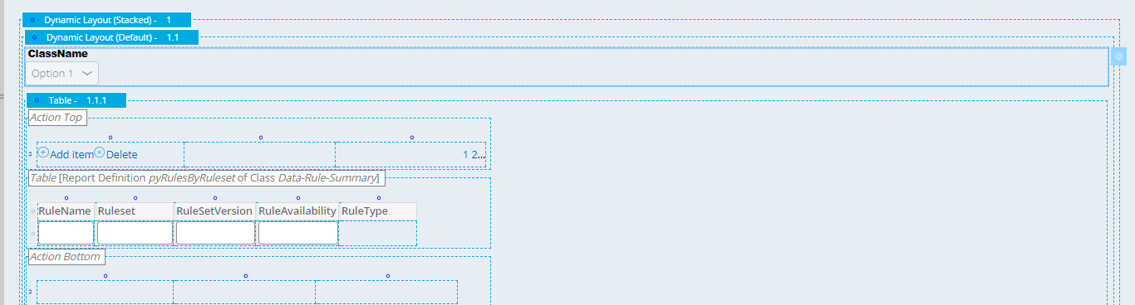

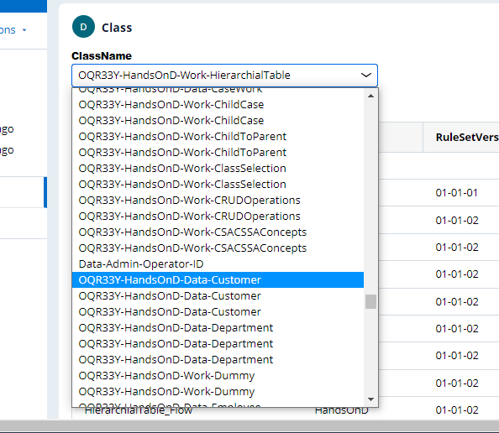

And inside that we have the classes when selected

